The Project Management Institute – North Saskatchewan Chapter

is pleased to announce:

Date:

Topic:

Speaker:

Location:

NOTE:

Agenda: 11:55 Announcements and Introductions

12:00-12:55 – Presentation

12:55-1:05 – Comments and Q&A

Questions regarding the program should be addressed to:

Veddy Mehta, Dir of Programs

Phone: 306-850-7092

Email: programs@pminorthsask.com

PMI Talent Triangle Skill: Technical Project Management Skill

Please refer to: PMI.org

The PMI Talent Triangle Defined
Skill Area | Definition
Ways of Working | (Previously Technical Project Management) Whether it’s predictive, agile, design thinking, or new practices still to be developed, it's clear that there is more than one way that work gets done today. That’s why we encourage professionals to master as many ways of working as they can - so they can apply the right technique at the right time, delivering winning results.
Power Skills | (Previously Leadership) These interpersonal skills include collaborative leadership, communication, an innovative mindset, for-purpose orientation, and empathy. Ensuring teams have these skills allows them to maintain influence with a variety of stakeholders - a critical component for making change.
Business Acumen | (Previously Strategic and Business Management) Professionals with business acumen understand the macro and micro influences in their organization and industry and have the function- or domain-specific knowledge - to make good decisions. Professionals at all levels need to be able to cultivate effective decision-making and understand how their projects align with the big picture of broader organizational strategy and global trends.

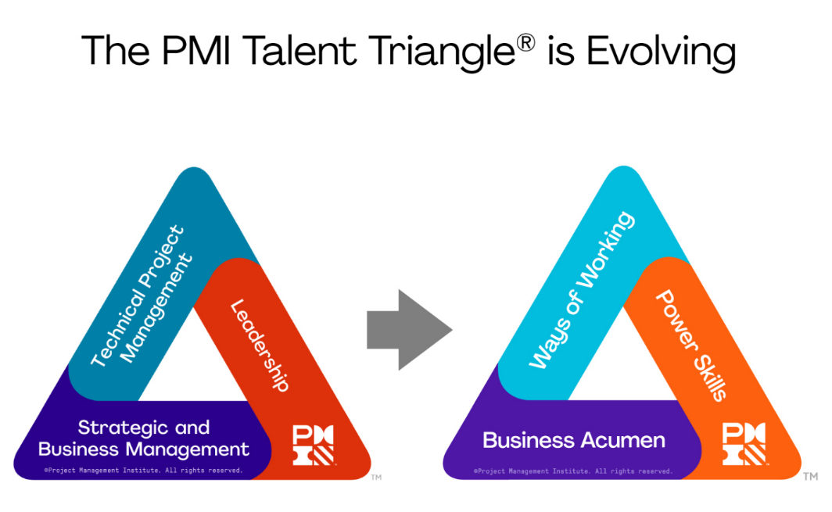

Speaker Biography:

xxxx

Presentation Title: xxxx

Presentation Overview:

xxxx

Presentation Learning Objective:

xxxx

Key Learning points
- xxx
- xxx

